AO Arena Accessibility Guide

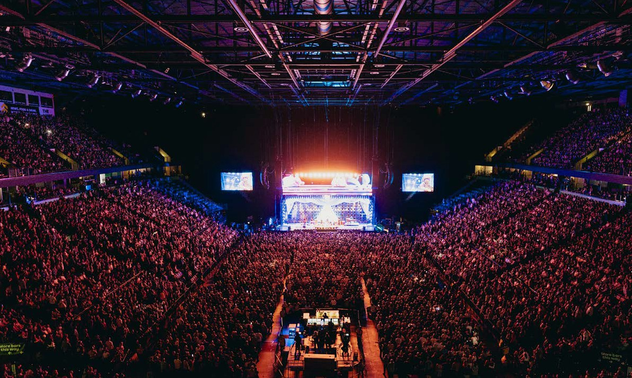

AO Arena is committed to disability awareness and takes an inclusive approach at each stage of the customer journey. Through our dedicated accessibility support service, we aim to provide a fair and equal service throughout your experience.

This guide is designed to assist patrons with accessibility requirements to enjoy their visit to AO Arena. It is an editable Word document so that you may change or increase the font to make it easier for you to read. For this reason, our contents use section numbers rather than page numbers for reference.

We offer a warm welcome to everyone and aim to offer an excellent level of service to all of our customers. All front-line staff have undertaken accessibility training and will do their best to ensure your visit is both enjoyable and safe. We really want you to enjoy your time with us so if anything happens whilst you are at AO Arena, please speak to one of our staff who will help as best as they can.

We are happy to answer any queries so please do not hesitate to contact us: Email: contactus@ao-arena.com

02

Contents
- Booking Accessible Tickets 04
Facilities for people who are Deaf / deaf / hard of hearing. 04
BSL Interpreter 05
- Accessing Seats 06
Accessing Seats in Lower Tier 06
Accessing Seats in Upper Tier 07
- Entrances 08
Getting from Victoria Station to City Room entrance. 08
Getting from Hunts Bank into the Arena 08
Getting from Trinity Tunnel into the Arena 08
External Venue Map 09
- Getting Here and Parking 10
Accessible Parking 10
Public Transport 10
- Box Office & Ticket Resolution Point 11
- Accessibility Inside the Venue 12
  - – Accessible Search Lanes 12
  - – Toilets 12
  - – Changing Facilities 12
  - - Quiet Spaces / Prayer Rooms / Breastfeeding space 12
  - - Food and Concessionary Stands 12
  - – Merchandise Stands 13
  - - Guests with Medical Requirements 13
  - - House Wheelchair / Wheelchair Storage 14
  - - Medical Assistance / Emergencies 14
Internal Venue Map 15
- Additional Services 16

Booking Accessible Tickets
1

All our accessible tickets are available to be purchased online via Ticketmaster.
If your access requirements are not met by the online booking system, please contact us at: contactus@ao-arena.com

Wheelchair accessible seats are in:

Access Platform 108 and 109. Access Platform 105, Row Z
Camera Platform - Each of which can seat one wheelchair guest and their personal assistant.
These areas are designated for guests with wheelchair accessible needs; however, the seats can be used for people with ambulant accessibility needs. Priority is for wheelchair users.

Ambulant accessible seats are in:

Block 105, Row Y: 3 steps down with a handrail, which is used for ambulant accessible guests.
Block 105, Row X: 10 steps down with a handrail, which is also used for ambulant accessible guests.
However, if you are able to sit wherever in the venue, we advise you booking your tickets and contacting AXS (our official ticketing partner to issue a companion ticket)

Facilities for people who are Deaf / deaf / hard of hearing.
The hearing loop is situated in Block 114 Rows L-X and also in the wheelchair accessibility platforms in AP 108, AP 109.
Furthermore, Row G-J in Block 114, Row X of Blocks 108 and 109 have intermittent coverage. Once you are seated you will need to switch to the T position on your hearing aid.
The hearing loop is connected to the touring sound desk - we give the touring sound engineer a cable which feeds our loop and we ask them to plug that into their sound desk. That then sends the signal of everything which goes into the mics out to that feed and into the induction loop (similar to the feed that goes out to the speakers).
We very occasionally have issues; however we ask customers to let us know straight away if they are having any difficulty picking it up. You can let us know by speaking to a steward or visiting the Guest Service Desk which is opposite Block 101.

BSL Interpreter
Should you require a BSL interpreter or an assisted performance – We advise booking tickets in a Camera Platform and contacting our team via contactus@ao-arena.com so they can assist with booking interpretation.
Please contact us as soon as possible so we can assist with your request.

Assistance Dogs

ADUK registered assistance dogs are welcome at the AO Arena.
We also welcome other trained assistance dogs. In this case, as we would not have a registration document to demonstrate the dog’s level of training, we need to ask that guests confirm the following. In order that we can allow them entry to an event, our guests must be able to guarantee that their dog complies with the following:

Can sit quietly without being distracted by the usual noise and bustle of an event.

Is trained not to toilet anywhere inside the venue. Staff will not be responsible for picking up after your dog if they are taking care of them during an event.

Will not jump on or approach any other members of the public.

Must be clearly marked – by lead, harness or coat – as an assistance dog.

The Equality and Human Rights Commission states that ‘Assistance Dogs’ are highly trained. This means that they:

will not wander freely around the premises

will sit or lie quietly on the floor next to their owner

are unlikely to foul in a public place

If your dog does not comply with these points, we may ask you to take it out of the venue.

Guests should contact us on contactus@ao-arena.com, at least two working days before the event they are attending so that we can make arrangements for their assistance dogs comfort and safety during their visit.
The dog can either accompany the guest into the auditorium, if appropriate seating has been booked, or venue staff will willingly look after your dog whilst you enjoy the event. We can provide a water bowl and blanket for your dog, if required.
It is possible that we may need to find an alternative seat for the guest if the original seat is not appropriate for a canine companion. In any event, we will discuss the best options with the guest to assure this is resolved.

Accessing Seats
2

Accessing Seats in Lower Tier
Please note access from the floor may be limited depending on the layout of the show – if unsure please contact our team.

Row
A | 73 Steps | 3 Steps From Floor
B | 70 Steps | 6 Steps From Floor
C | 67 Steps | 9 Steps From Floor
D | 64 Steps | 12 Steps From Floor
E | 61 Steps | 15 Steps From Floor
F | 58 Steps | 18 Steps From Floor
G | 55 Steps Down | First 10 With A Handrail
H | 52 Steps Down | First 10 With A Handrail
J | 49 Steps Down | First 10 With A Handrail
K | 46 Steps Down | First 10 With A Handrail
L | 43 Steps Down | First 10 With A Handrail
M | 40 Steps Down | First 10 With A Handrail
N | 37 Steps Down | First 10 With A Handrail
P | 34 Steps Down | First 10 With A Handrail
Q | 31 Steps Down | First 10 With A Handrail
R | 28 Steps Down | First 10 With A Handrail
S | 25 Steps Down | First 10 With A Handrail
T | 22 Steps Down | First 10 With A Handrail
U | 19 Steps Down | First 10 With A Handrail
V | 16 Steps Down | First 10 With A Handrail
W | 13 Steps Down | First 10 With A Handrail
X | 10 Steps Down | With A Handrail

Accessing Seats in Upper Tier
Please note from the concourse it is 16 steps up with a handrail to the bottom of the upper tier. The upper tier has a handrail however this is intermittent.
Customers can also take a lift to the top of the upper tier to access seats.

Row | From bottom of Tier 2 | From top of Tier 2
A | 3 Steps Down | 50 Steps Down
B | 2 Steps Up | 45 Steps Down
C | 5 Steps Up | 42 Steps Down
D | 8 Steps Up | 39 Steps Down
E | 11 Steps Up | 36 Steps Down
F | 14 Steps Up | 33 Steps Down
G | 17 Steps Up | 30 Steps Down
H | 20 Steps Up | 27 Steps Down
J | 23 Steps Up | 24 Steps Down
K | 26 Steps Up | 21 Steps Down
L | 29 Steps Up | 18 Steps Down
M | 32 Steps Up | 15 Steps Down
N | 38 Steps Up | 12 Steps Down
P | 41 Steps Up | 9 Steps Down
Q | 44 Steps Up | 6 Steps Down
R | 47 Steps Up | 3 Steps Down

3 Entrances
Please note that access to the arena complex is restricted to ticket holders only on event days.

Getting from Victoria Station to City Room entrance.
Guests can take the lift located to the right-hand side of the stairs within Victoria station. The lift to the bridge level connects Victoria Station to the City Rooms entrance at the Arena. Maximum distance from Victoria Station to entrance is 180 metres. We recommend that our accessible guests use this entrance if they are seated in the 100 / 200 numbered blocks as this is the most accessible route for these seat locations.
Our VIP entrance is also located in City Rooms for VIP, Premium and Suite ticket holders.

Getting from Hunts Bank into the Arena
The Hunts Bank entrance is accessible via the stairs or a lift to the right-hand side of the stairs. Maximum distance to the lift from the entrance point is 50 meters. There is also a ramp available here for our guests with tickets to access the Heineken Skyline Lounge with a lift up to the rooftop bar space.

Getting from Trinity Tunnel into the Arena
Guests who have tickets for the event floor will need to access the arena via Trinity Tunnel located on Trinity Way. Here there is a lift down to the event floor and escalators for those able to use them.

Please see the map on the next page.

External Venue Map

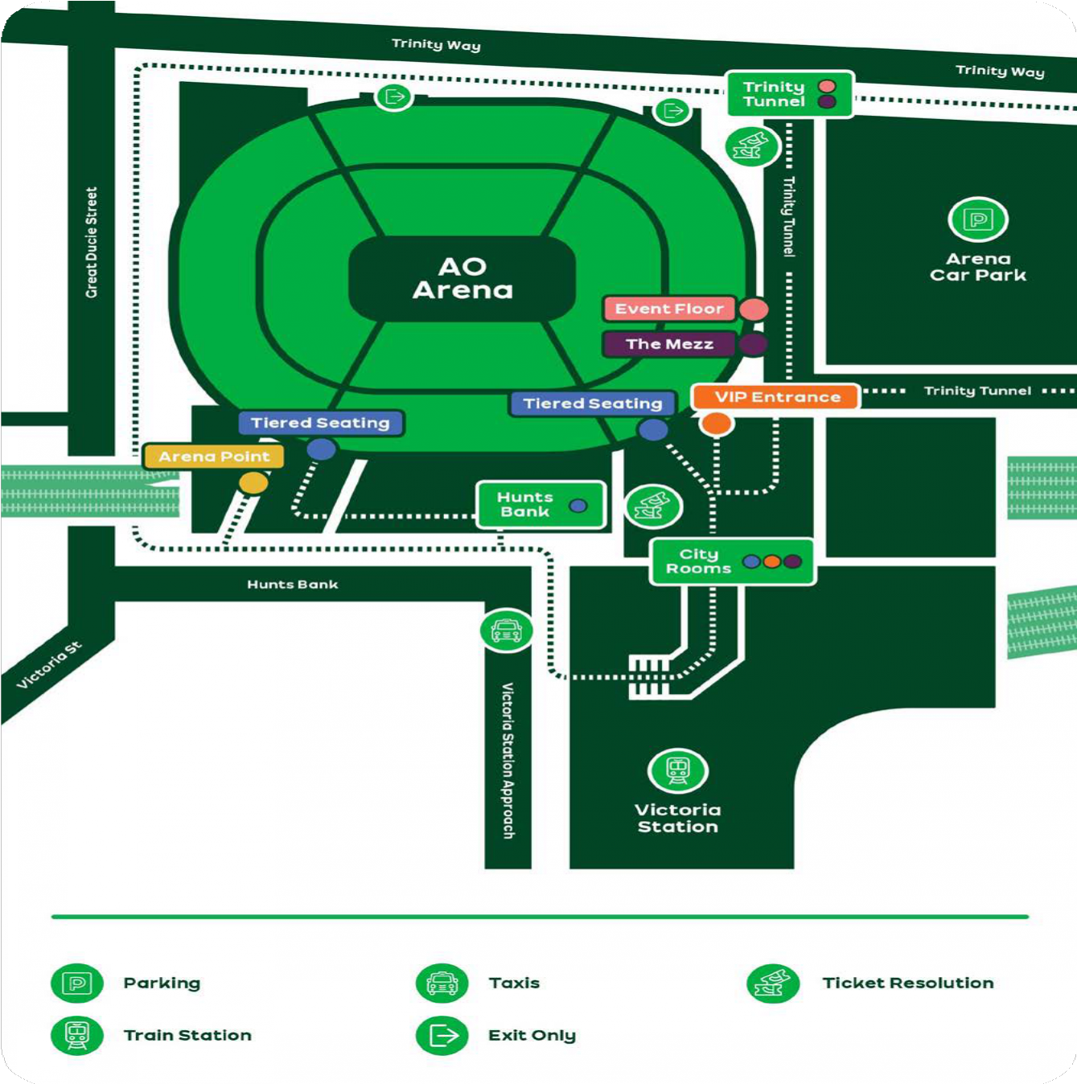

Getting Here and Parking
4

Accessible Parking
Arena postcode: M3 1AR
CitiPark operate our on-site car park. Blue Badge Bays cannot be specifically booked and are on a first come first served basis. If there are spaces available, an attendant will direct guests upon presenting their blue badge. There are 40 Blue Badge parking bays.

Public Transport

Rail:
The Arena is located within the Manchester Victoria Station complex where many national services operate to and from on an event day. The main station in Manchester is Piccadilly Station which is approximately 0.7 miles away. There are several buses and Metrolink services that operate directly to Piccadilly from Victoria Station. There is a free bus that runs frequently from outside the front of Piccadilly Station that takes you to all train stations in the city centre, with a stop outside Victoria Station and the arena.

Metrolink:
Trams run directly to Victoria Station from Rochdale, Bury, Altrincham, East Didsbury.

Bus:
Shudehill bus station is approximately 0.5 miles away and operates many of the main bus services in the centre of the City and Greater Manchester and national bus networks operate from here.
Further bus services in Manchester operate at Piccadilly Gardens bus station, which is 10-15 mins walk from the arena.

For guests looking to plan their journey, we recommend they use the Transport for Greater Manchester website: https://tfgm.com/

Box Office
5
& Ticket Resolution Point

The box office is only open on event days one hour before the event doors. The box office is located off Trinity Way and is fully accessible with:

- Low level counter

- Hearing Loop

- Staff can provide information in large type on request

- A magnifying glass is available for customers

- The floor service is level

- Staff who are trained in disability awareness

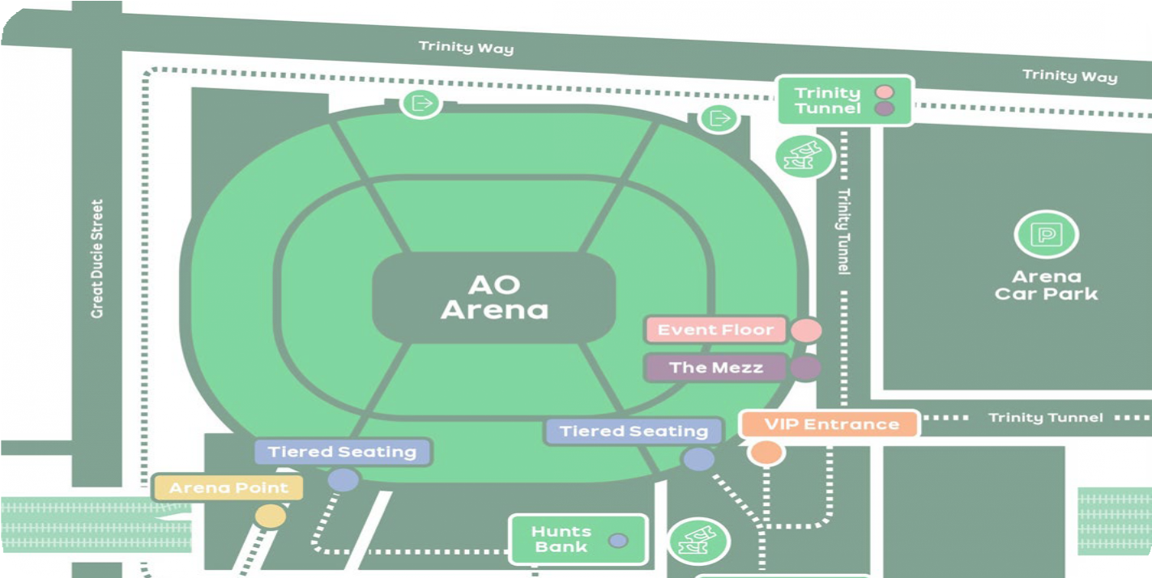
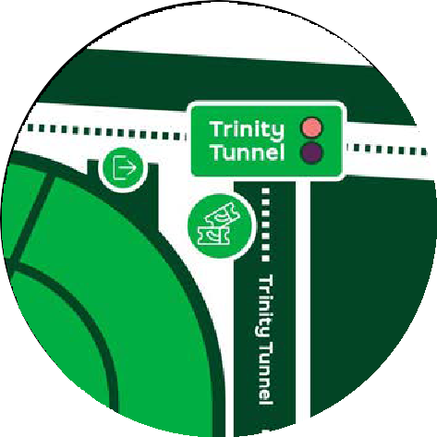

Accessibility Inside the Venue
6

– Accessible Search Lanes
If you have difficulties with queuing due to your accessibility requirements, each entrance has an accessible search lane. Staff on these lanes will be looking to help customers who require this, it is designed to allow for a smoother and quicker entry process for accessibility customers. If you would benefit from using this, please do approach the staff and let them know and they will be happy to help. You do not need any documentation to access this.

– Toilets
Toilets are located near to Blocks 108 / 109 & Blocks 116, 120 & 119. This is including accessible toilets within the male and female toilet, as well as all-gender toilets, and separate radar key toilets if required.

– Changing Facilities
We have a changing place toilet in operation near to Block 110. This can be accessed via radar key, so we encourage you where possible to bring your own, but please do speak with the nearest steward to the facility or any Supervising Steward (noticed as they are wearing purple/silver Showsec uniform) to offer assistance with access.
This toilet is larger than a standard wheelchair accessible toilet and includes a height-adjustable changing bench, a hoist and room for up to two PAs.

- Quiet Spaces / Prayer Rooms / Breastfeeding space
If you need support or you are feeling uncomfortable and would like to be shown to a quiet space, then please ask a member of stewarding staff or our customer services team by Block 101 who will be happy to assist you during a show. We will always endeavour to find a quiet space. This may or may not be within view of the show.
If you need a prayer room, a space can be found for that too. Again, mention it to a steward and a space will be found. If you need a space to breastfeed, this will also be accommodated.
If you know in advance of an event that you may need to use a quiet space, please contact us with as much notice as possible on contactus@ao-arena.com

- Food and Concessionary Stands

There are concession stands located around the concourse and at floor level. All food and drink areas have level access. There are lowered counters at the bars and the menus are available
in large print on request. All areas are well lit and the floors are level and anti-slip. All counters accept card and contactless payments. You are permitted to take food and drink into the auditorium.
Please note that we do not permit food and drink to be brought into the venue, however should you require the items due to a medical requirement, please see information in Section 6.7 of this document.

– Merchandise Stands
There are merchandise stands located around the concourse. A lowered counter is available at Blocks 112, 119 and the floor merchandise stand. All counters accept card and contactless payments. Merchandise for concerts is supplied by the touring production. We will ask tours to
provide event programmes or running orders in alternative formats including large print or audio versions. However, this is not always possible and we have limited control over the stock that the events bring. If you would like information such as this in an alternative format, please let us know in advance of the event and we will campaign for it to be included in the stock.
We will do our best to produce large print event running orders on the day of the event. Please be aware that some shows may either not provide a running order or may object to us issuing them to the public at all. The Customer Services staff should be able to find out information for you on the day of the event.

- Guests with Medical Requirements
Medication for medical conditions, or food or drink to manage a medical condition can be brought into the venue.
We suggest contacting us in advance of the visit for advice, prior written acknowledgement from us of the guests requirements, or should you have any concerns or questions about the items
a guest wishes to bring along. Having an email from the venue is the quickest way through the process and a list of ‘exceptions’ is issued to staff on each entrance when advance warning has been given. This should reduce any questioning a guest may be subject to on entrance.
Please email our accessibility team before a visit to arrange this on contactus@ao-arena.com.
Please be aware that food and drink should be limited to the guest and should be for a medical condition. A full picnic, for example, is likely to be refused entry. A packet of biscuits and a small drink, less so.
Guests can also bring any supporting documents to the venue with them should they wish, for example letters from the doctor or prescriptions in their name. In general, if it is possible, we request that they bring medication inside its original container (blister packs, boxes or

bottles). Please do not be offended if a member of the arena medical team is asked to verify the medication that they are bringing in. This should happen in a quiet and considerate way, away from the passing public.

- House Wheelchair / Wheelchair Storage
House wheelchairs are available from Guest Services (opposite Block 101) this includes wheelchairs capable of 50 stones. If you require any assistance, please speak to a steward or an arena host who can help. Wheelchairs can be used within the Arena itself to assist customers around the concourse to their seating location and back to the venue doors. Please note our
venue wheelchairs can only be used within the Arena and cannot be taken outside. Unfortunately, they are not able to remain with the guest for the duration of the show as we may need them to help other customers.
If a guest requires a wheelchair to get to the venue but has not booked or doesn’t need wheelchair accessibility seating, we will happily look after this for you.
Please ask the guest to visit Guest Services (opposite to block 101), where we will exchange their wheelchair for a wristband. Before they leave the venue, please just ask that they return to Guest Services who will provide the wheelchair upon presentation of the wristband.
Please note, if the guest needs an assistant or companion to collect their wheelchair on the guests behalf, please make sure they are the ones with the wristband.

- Medical Assistance / Emergencies
Trained first aiders, EMTs and Paramedics are available for all events and can be summoned by our stewards.
Our staff are fully trained in the evacuation of the venue. In the event of an emergency there will be an audible alarm in all areas. Stewards will be on hand to assist with the exit of all customers. Personal Assistants must be able to assist the person they are attending with to leave the building in an emergency. There are transfer chairs available. These have a safe working load of (weight) and staff are trained how to use them. The stairwells in the building are designated refuges and they have mechanisms to protect you from fire until you can be assisted from the venue.

Please see the map on the next page.

Internal Venue Map


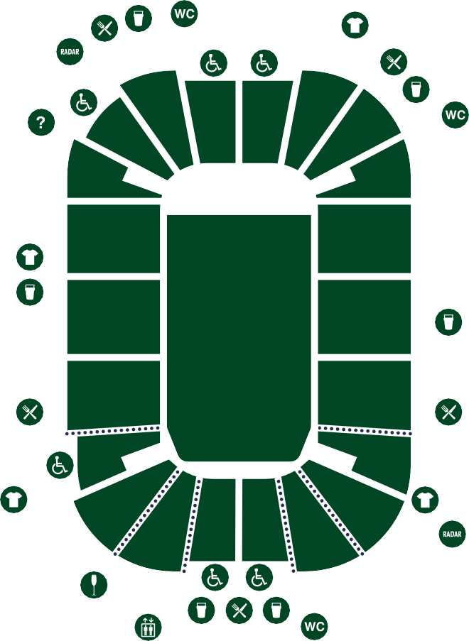











221
220
219
218
222
217
201
121 120 119 118
122
117
216
Hunts Bank
City centre
101
stage
116
202
215
102 115
External lift to street level
Access to Victoria Station and Metrolink
203
103
Seated / Standing Floor
114
214
Trinity Way
Exit Only Car Park
104 113
204
213
105
112
205
106
111
107 108 109 110 212
206
211
207
210
City Room
City centre
208
209
Trinity Way
Exit Only Car Park

External lift to street level
External lift access to Victoria Station and Metrolink


Toilets including accessible facilities

 Bar Food
 Radar Key Accessible Toilets  Public Lift
 Accessible Area
Access to Floor via Stairs
 Merchandise

Access to Prime Experience Bars

Information Desk

Additional Services
7

We offer women’s sanitary products, ear plugs and other useful items should a guest require it at

Guest Services at Block 101.
If there are any questions that you are unsure of the answer to and can’t locate the answer within this guide / cannot be resolved in time pre-event; please direct the guest to one of our Guest Services desks on the event date in question. We have three desks located opposite Block 101 in Hunts Bank entrance, in City Rooms entrance to the left of the bridge next to the Merchandise Stand and at Ticket Resolution located inside the entrance to Trinity Tunnel. Our team of experienced arena hosts will be able to assist with any enquiries at all of these locations should the guest require assistance.
Please note that our Guest Services location located at Hunts Bank entrance is open for all shows. The other desks availability and opening times will vary depending on production. For clarity on the opening times of these desks, please refer the guests to their ‘know before you go’ email or indeed email us on contactus@ao-arena.com.

